LinkedIn Influence Lab
Industrial Capstone Report: AI-guided personal branding with ChatGPT and Taplio
Prepared for: Aarav Sharma | Persona: Job Seeker
Project code LIL-2025-P1 | Generated 2026-11-09

1. Executive summary
This capstone delivers a complete, reproducible personal-branding system for Aarav Sharma. It combines AI-assisted ideation, a 6-week content calendar, a Taplio scheduling queue and an analytics loop. The primary path is 'Job Seeker'; the two alternative paths are fully supported and compared below.
Deliverable | Result
Branding audit | 19/100 (Starting out); 10 gaps with fixes
Content ideas | 21 generated (brief requires 15+)
Post drafts | 18 drafts, average quality 93/100 (brief requires 10+)
Content calendar | 18 slots over 6 weeks
Engagement tracking | 12 posts, 4.63% engagement (DEMO)

2. Project overview and client background
Purpose: help professionals build a strong personal brand on LinkedIn by combining Taplio's content workflow with ChatGPT-driven ideation and optimization.
- Outcomes: consistent content strategy, AI-assisted visibility, engagement monitoring, reproducible framework.
- Client needs: professional visibility, a consistent content pipeline, a scalable system for ideation, scheduling and analytics.
- Constraints: Taplio free tier (basic features), ChatGPT integration, business-ready reproducible deliverables.

3. Business problem
LinkedIn has over a billion users, yet most professionals fail to use it for career growth because of inconsistent posting, no content plan, and little time for engagement and analytics. This project answers with a structured, AI-guided lab that automates ideation, strategy alignment and performance monitoring.

4. User stories: all three paths explored
Path | User story | Rhythm | Pillar mix | KPIs
Working Professional | I want a guided content workflow so that I can post consistently and grow my personal brand. | Tue, Wed, Thu | Career Insights 29%, Thought Leadership 24%, Industry Trends 24%, Actionable Tips 24% | Impressions, Comments, Profile visits
Job Seeker | I want to optimize my LinkedIn presence so that I attract recruiters and opportunities. | Mon, Wed, Fri | Actionable Tips 33%, Personal Journey 28%, Career Insights 22%, Industry Trends 17% | Profile visits, Recruiter messages, Connection requests
Thought Leader / Entrepreneur | I want to scale influence by using AI to generate impactful content aligned with my brand voice. | Tue, Thu, Sat | Thought Leadership 33%, Industry Trends 28%, Actionable Tips 22%, Personal Journey 17% | Followers gained, Shares, Inbound leads

5. Solution and AI-guided workflow
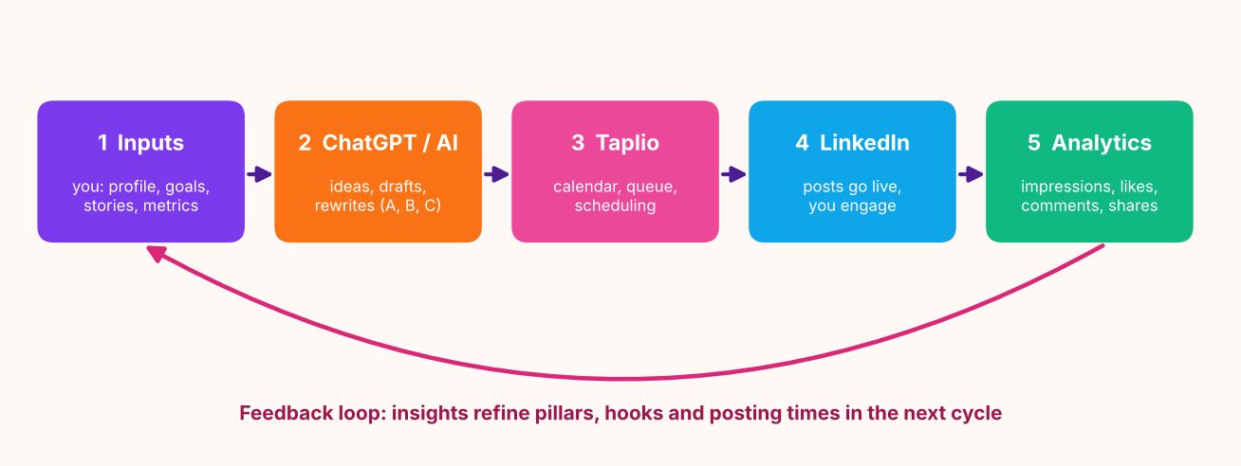
Inputs (you) feed the AI plugin, whose drafts you review; approved posts go to Taplio, publish on LinkedIn, and their metrics return as analytics that refine the next cycle's inputs. The pipeline automates everything except the steps that must stay human: reviewing, publishing and reporting real numbers.

6. Phases, timeline and backups
Phase | When | Goal | Output folder | Backup
1. Foundation: Audit & Pillars | Week 1 | Audit the LinkedIn profile, benchmark role models, define 3-5 content pillars. | phases/phase_1_foundation | backups/ (zip per run)
2. AI Ideation & Drafting | Week 2 | Generate 15+ ideas, draft 10+ optimized posts, pick 2-3 pilot posts. | phases/phase_2_ideation_drafting | backups/ (zip per run)
3. Calendar & Taplio Setup | Week 3 | Build the 6-week content calendar and the Taplio-ready scheduling queue. | phases/phase_3_calendar_taplio | backups/ (zip per run)
4. Publish & Track | Weeks 4-5 | Publish consistently, log likes / comments / shares / impressions per post. | phases/phase_4_publish_track | backups/ (zip per run)
5. Analytics & Review | Week 6 | Analyse engagement, refine the strategy, produce the performance review. | phases/phase_5_analytics_review | backups/ (zip per run)

7. Branding and content strategy
Pillar | Share | Posts | What it covers
Actionable Tips | 33% | 6 | Checklists, templates and habits people can use today.
Personal Journey | 28% | 5 | Honest stories: wins, mistakes and what you are learning.
Career Insights | 22% | 4 | Hard-won lessons about growth, promotions and decisions.
Industry Trends | 17% | 3 | What is changing in your field, explained in plain English.

Formats: text posts, carousels (built as a PDF in your design tool), polls and micro-stories. Engagement strategy: reply to every comment within two hours, comment on 5 peers' posts daily, share curated content with a source.

8. AI-guided prompt templates
- Template A: Generate 5 engaging LinkedIn post ideas about [industry/career topic].
- Template B: Rewrite this draft in a professional but relatable tone.
- Template C: Summarize this article into a LinkedIn post with 3 key takeaways.

9. Results and analytics
DEMO DATA: the numbers below are simulated for layout preview only.

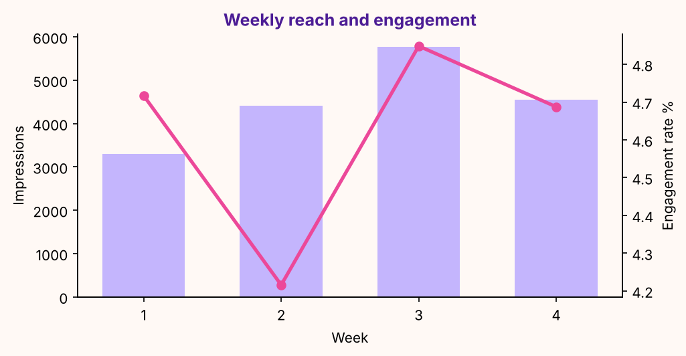
What we saw | What to do next
'Actionable Tips' is your strongest pillar (5.3% engagement). | Raise its share of the next calendar by about 10 points; keep the others for range.
Micro-story posts perform best (5.1%). | Use this format at least twice a week; test a new hook style inside it.
Wednesday posts lead on engagement. | Move one more post to Wednesday (same time of day) and compare.
Engagement rate is down 1% from first to latest week. | Review the latest week's hooks against the first week's winners.
1.8% of impressions became profile visits. | Make sure the headline and Featured section convert those visits (see the audit).

Criterion | Weight | Score
Content Quality & Relevance | 30% | 93.3
Engagement Growth | 20% | 49.7
Personal Branding Alignment | 15% | 100.0
Documentation & Clarity | 10% | 0.0
Overall (provisional) |  | 70.6

10. Bias and ethical considerations
- Avoid over-automation: nothing is queued as approved until you tick Human reviewed.
- Inclusive and neutral language: the quality checker flags non-inclusive terms and suggests replacements.
- Attribute sources: statistics or studies without a named source are flagged; Template C always adds a Source line.

11. Risks and mitigations
Risk | Mitigation | Implemented as
Low engagement | Adjust posting time and content type | Insights page flags rate < 2% and suggests hook / format / time tests.
Free-tier limits in Taplio | Supplement with manual LinkedIn analytics | Manual entry form and a flexible CSV importer for LinkedIn or Taplio exports.
Over-reliance on AI | Ensure human review for authenticity | Every draft has a Human reviewed gate; the approved-only Taplio queue excludes the rest.
Consistency drop-off | Use scheduling to avoid gaps | Taplio queue, .ics reminders and a consistency score on the dashboard.

12. Technical architecture
Python 3.10+, Streamlit UI, pandas, openpyxl, python-docx, matplotlib and requests. Modules are layered: inputs and plugins, engines (ideation, drafting, quality, planner), phases and pipeline, reports and backups. Plugins (AI, export, import) are drop-in files. All paths come from one module (paths.py); every phase writes to its own folder and is zipped to backups/ when it finishes. See docs/03_PROJECT_STRUCTURE_GUIDE.md.

13. How to reproduce
- Run run_app.bat (Windows) or run_app.sh; open the local address shown.
- Fill Inputs, optionally connect an AI plugin, press Run full pipeline.
- Review drafts, approve them, schedule in Taplio, log metrics, rebuild deliverables.
- Details: HOW_TO_RUN.txt and docs/04_USER_GUIDE_FOR_BEGINNERS.md

14. Appendices
- Prompt templates A-C: templates/prompt_templates.md
- Content calendar sample: sample_data/ and deliverables/01_content_calendar
- Engagement tracking sheet: deliverables/03_engagement_dashboard
- Profile optimization checklist: templates/profile_optimization_checklist.md

